**Summary of Power BI Dashboard**

**Zepto Inventory & Supply chain Analytics**

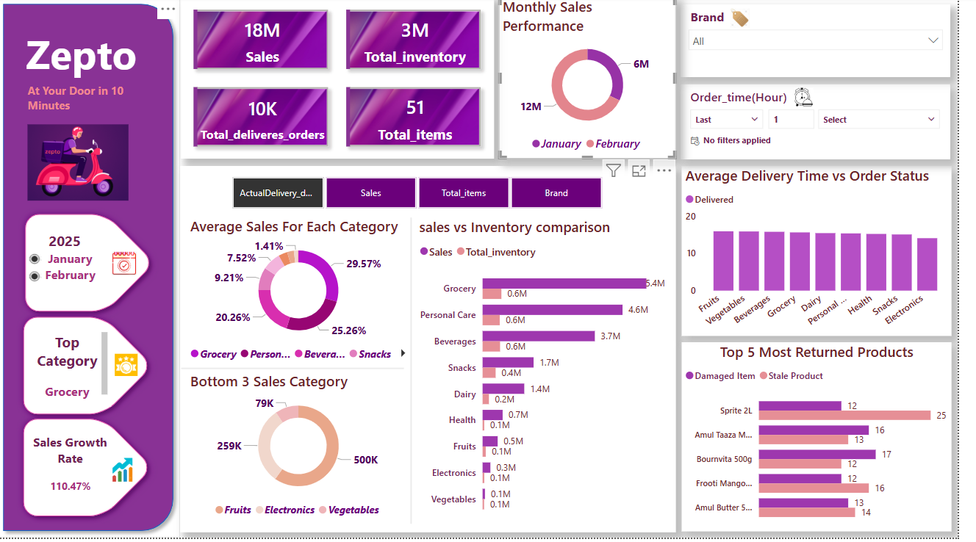

This Power BI dashboard provides a comprehensive analysis of Zepto’s sales and inventory performance. Here's an overview of the key insights presented:

**1. Overview Metrics**

* **Total Sales:** 18M
* **Total Inventory:** 3M
* **Total Delivered Orders:** 10K
* **Total Items Available:** 51

**2. Monthly Sales Performance**

* **January:** 12M sales
* **February:** 6M sales
* Indicates a decline in February compared to January.

**3. Sales by Category**

* **Top Performing Category:** Grocery (29.57%)
* Other major categories:
  + **Personal Care:** 25.26%
  + **Beverages:** 20.26%
  + **Snacks:** 9.21%
* **Bottom 3 Categories:**
  + Fruits (79K), Electronics (259K), and Vegetables (500K) show the lowest sales.

**4. Sales vs Inventory Comparison**

* Grocery has the highest sales (5.4M) but relatively low inventory (0.6M).
* Personal care follows (4.6M sales, 0.6M inventory).
* Beverages, snacks, and dairy also show strong sales.
* Fruits, electronics, and vegetables have the least sales and inventory.

**5. Delivery Performance**

* The average delivery time remains consistent across all categories.
* Fruits, vegetables, grocery, and dairy have slightly higher delivery times.

**6. Product Returns Analysis**

* **Most Returned Products:**
  + Sprite 2L (highest return: 25 stale, 12 damaged).
  + Amul Taaza Milk, Bournvita 500g, Frooti Mango, Amul Butter also show high return rates.
* **Primary Reasons for Returns:**
  + Stale product is the main cause, followed by damaged items.

**7. Additional Highlights**

* Grocery is the best-performing category with a 110.47% growth rate.
* Filters for brand and order time are available for further analysis.

**Conclusion**

The dashboard provides valuable insights into sales, inventory management, delivery efficiency, and product returns. The company can focus on:

* Addressing declining sales in February.
* Improving inventory levels for high-demand products (e.g., Grocery).
* Managing high return rates for specific products (Sprite 2L, Amul products).
* Optimizing delivery times for better efficiency.